**School Supplies Mr. Jacob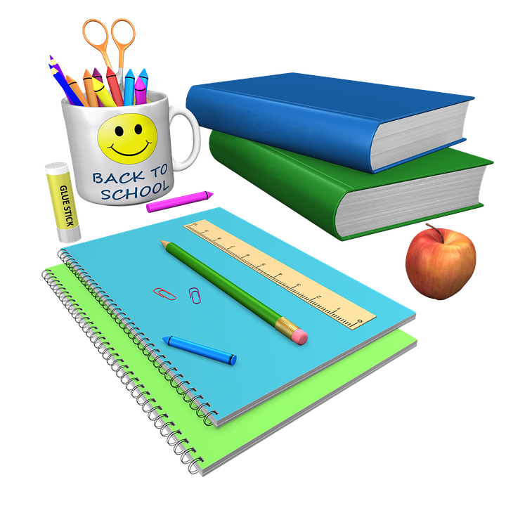 Classroom 4**

1. **Disinfectant Wipes**
2. **Hand Sanitizer**
3. **Deodorant**
4. **Facial Tissues**
5. **Toothbrush**
6. **Change of clothes**
7. **Lysol Spray (1 Bottle)**
8. **Your child’s favorite snack.**